
MATHEMATICS DEPARTMENT
Year 11 Specialist – 2016
Test Number 2: Mathematical Proof
Resource Free

Name: __________SOLUTIONS_______________________ Teacher: DDA
Marks: 39
Time Allowed: 40 minutes
Weight: 2.5%
Instructions: You ARE NOT permitted any notes or calculator. Show your working where appropriate remembering you must show working for questions worth more than 2 marks.
_________________________________________________________________________
1 Consider the statements:
I If you have a driver’s licence then you are over 16.
II If you are not over 16 then you do not have a driver’s licence.
Which of the following is true?
A II is the converse of I.
B II is the contrapositive of I.
C II is a counterexample of I.
D II is the negative of I.
E II is the reverse of I.

[1 mark]
2 Consider the argument:
All fish live in water.
A turtle lives in water.
Therefore a turtle is a fish.
The argument is:
A a contrapositive
B inductive
C a contradiction
D invalid
E a counterexample.

[1 mark]
3 If is true then which statement is true?
A P Q
B P Q
C Q P
D Q P
E

[1 mark]
4 The values x = 3, y = −2 would be a counterexample to which of the following?
A x > y x2 > y2
B x > y
C x > y xy > y2
D x > y x2 > xy
E x > y

[1 mark]
5 You would use the SAS test to prove which pair of triangles congruent? (Circle the correct answer)
A 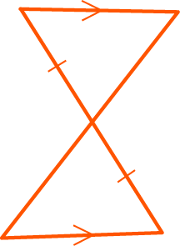
B 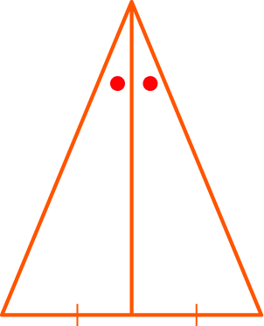
C 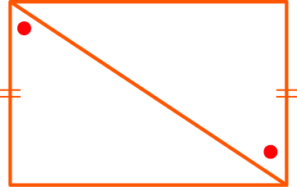
D 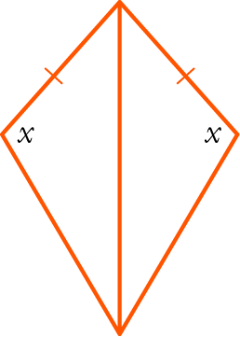
E None of the above.

[1 mark]

6 Write the statement below using mathematical notation.
For all rational numbers x there exist integers p and q where q is non-zero such that .

∀x ∈ Q, [1 mark] ∃ p, q ∈ Z, q ≠ 0 [1 mark] :

[3 marks]

7 For the statement:
If you drink too much alcohol then you will get alcohol poisoning.
a Write the converse.

If you get alcohol poisoning then you drink too much alcohol.

b Write the inverse.

If you do not drink too much alcohol then you will not get alcohol poisoning.

c Is the statement an equivalence? Give reasons.

Statement is true and converse is true [1 mark], therefore statement is an equivalence.

[4 marks]

8 Consider the two premises:
P: A quadrilateral is a rhombus.
Q: A quadrilateral has diagonals that bisect each other at right angles.
a Write P Q.

If a quadrilateral is a rhombus then the quadrilateral has diagonals that bisect each other at right angles.

b Write Q P.

If a quadrilateral has diagonals that bisect each other at right angles then the quadrilateral is a rhombus.

c Is it true that P Q? If so, write a statement linking P and Q using iff.

True or False? True (no mark)

A quadrilateral has diagonals that bisect each other if and only if the quadrilateral is a rhombus.

[3 marks]
9 Complete the proof that is irrational.
Proof: Assume that is rational, i.e. ∃ m, n ∈ Z, n ≠ 0 such that,
where m, n have no common factors.
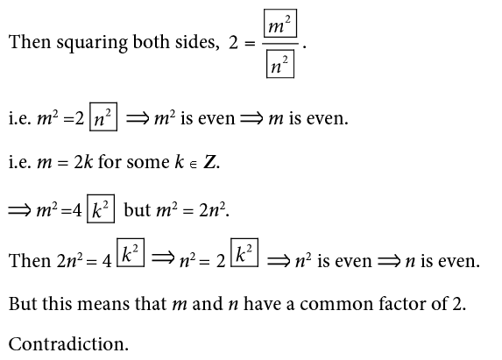
∴ is irrational.

[6 marks]

10 For each statement below, consider the contrapositive statement to determine whether or not the statement is true. Justify your reasoning.

a If pensioners have electronic devices then they send emails.
Contrapositive: If pensioners do not send emails then they do not have electronic devices.
Contrapositive may not be true. They may have electronic devices that do not do emails or use the library computer to send emails.
If the contrapositive is not true the original is not true.

b If a number is divisible by 4 then it is even.
Contrapositive: If a number is not even then it is not divisible by 4.
Contrapositive is true.
If the contrapositive is true the original is also true.

[5 marks]

11 In the diagram, AB ⊥ AC, AD ⊥ BC, BD = 4, DC = 9, AD = x.
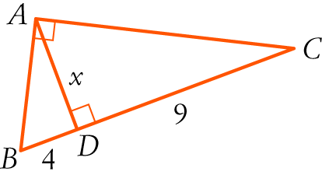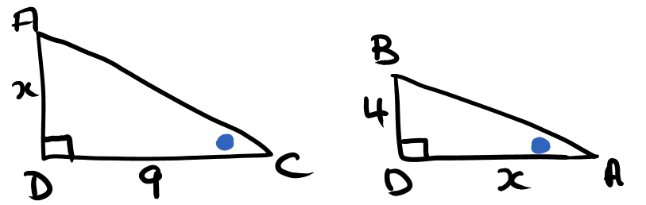

a Prove that Δ ABD ||| Δ CAD. Make sure you justify every line with a reason or rule.

In $∆ABD$ and $∆CAD$:
$∠BDA=∠ADC$ ( both $90°$ )
$∠BAD=∠ACD$ ( both complementary to $∠ABD$ )
$∴∆ABD$ $||| ∆CAD$ ( AA )

b Hence find the value of x.

(matching sides in similar triangles are in proportion)
∴ x2 = 36
∴ x = 6 (x > 0)

[6 marks]
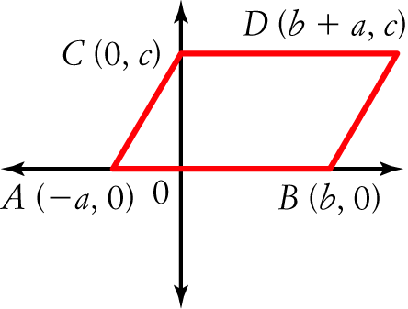
12 Consider the diagram with coordinates (−a, 0), (b, 0), (0, c), (b + a, c) representing the points A, B, C, D respectively, such that ABDC is a parallelogram.

a Determine the length of each of the following in terms of $a,b$ and $c$.

AB = $a+b$ | CD = $a+b$
AC = $\sqrt{a^{2}+c^{2}}$ | BD = $\sqrt{a^{2}+c^{2}}$
AD = $\sqrt{{\left(2a+b\right)}^{2}+c^{2}}$ | BC = $\sqrt{b^{2}+c^{2}}$

b Hence, write an expanded expression for each of the following in terms of $a,b$ and $c$
i) AB2 + DB2 + DC2 + CA2
$$={\left(a+b\right)}^{2}+a^{2}+c^{2}+{\left(a+b\right)}^{2}+a^{2}+c^{2}$$
$$=4a^{2}+2b^{2}+4ab+2c^{2}$$

ii) AD2 + CB2
$$={\left(2a+b\right)}^{2}+c^{2}+b^{2}+c^{2}$$
$$=4a^{2}+4ab+{2b}^{2}+2c^{2}$$

c What property of a parallelogram does this demonstrate?

The sum of the squares of the diagonals equals the sum of the squares of the side lengths.

[2,2,2,1: 7 marks]

